PAM SOP :

Step 1 : Install docker-
Add docker repo:-
dnf config-manager --add-repo https://download.docker.com/linux/centos/docker-ce.repo
dnf install -y docker-ce docker-ce-cli containerd.io
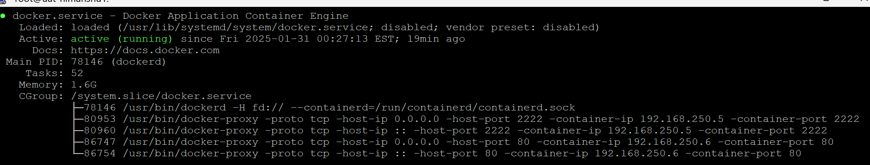
Step 2 : Execute this command to download and execute the jumpserver installation.
curl -sSL https://github.com/jumpserver/jumpserver/releases/latest/download/quick_start.sh | bash
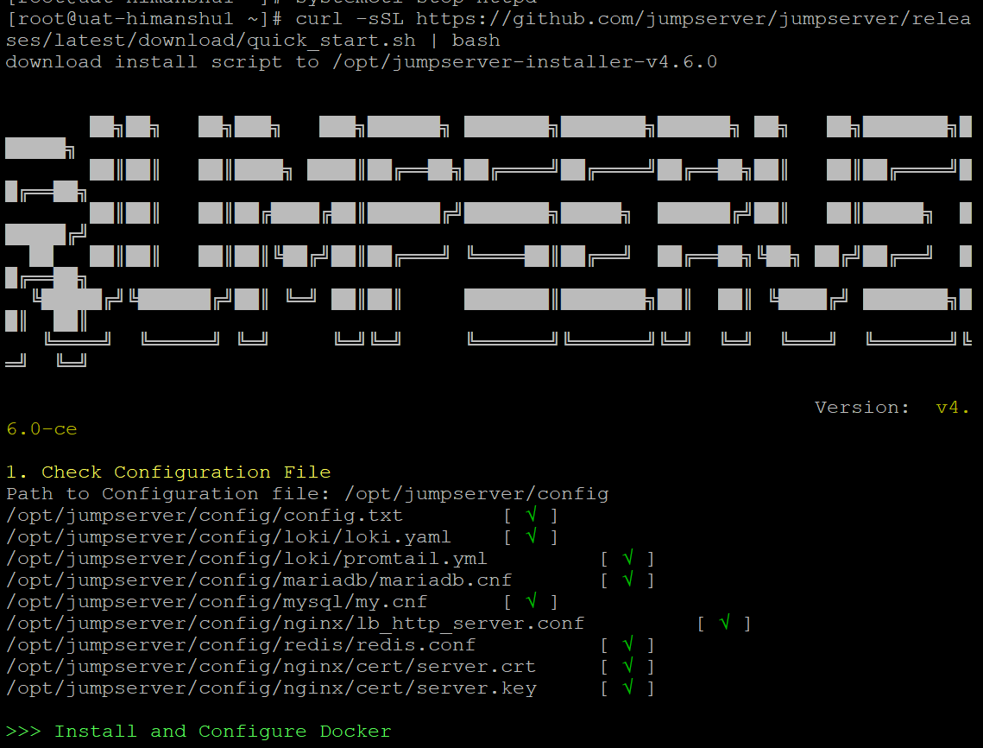
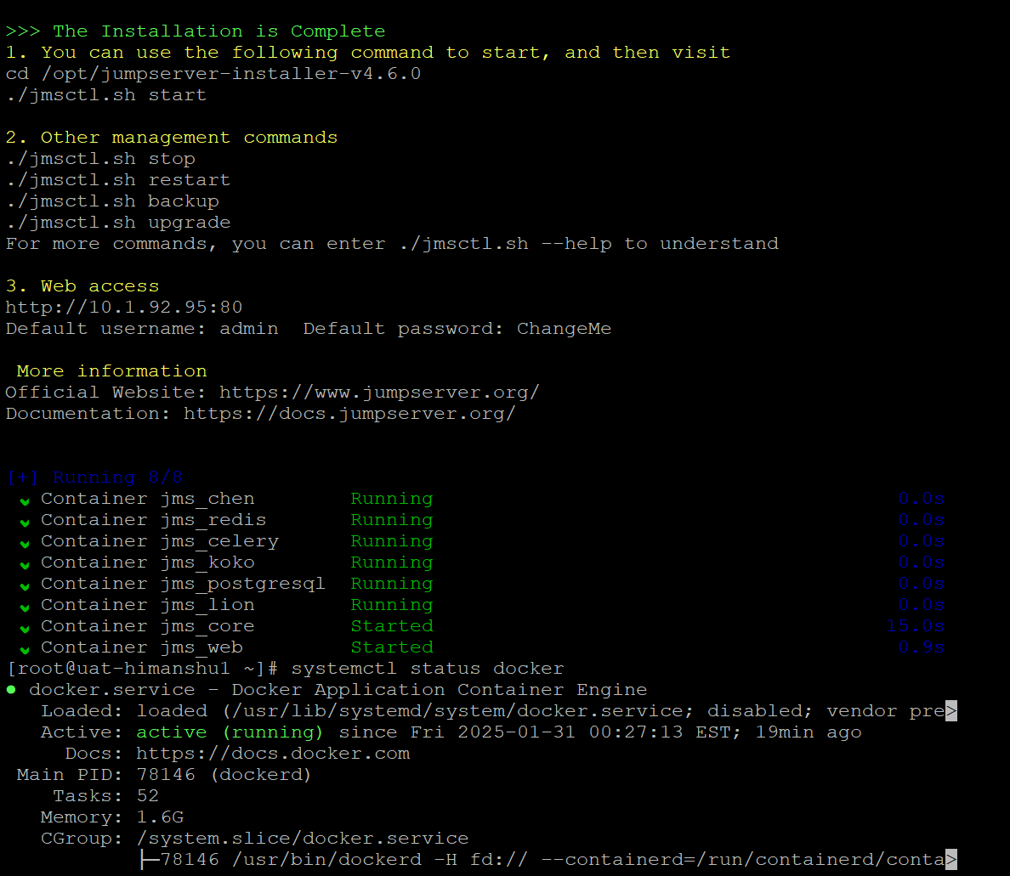
Step 3: Now access the ip in browser i.e. 10.1.92.95 (no port needed)
The default id is admin and password is ChangeMe
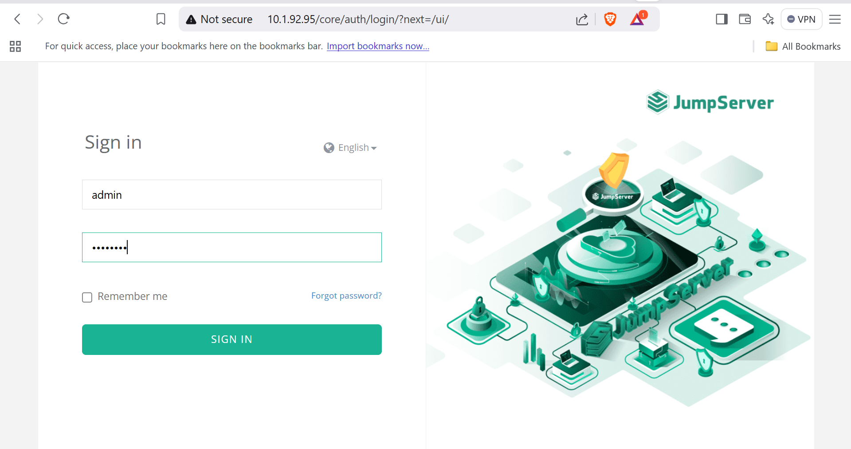
Step 4 : Change the password after first login, and accept the terms and conditions.

To view access and error logs go inside the docker - docker exec -it 802ca779e481 bash
cd /var/log
Here we can see access and error logs

